# **ITERATIVE MODEL**

The iterative process model is a software development life cycle (SDLC) approach in which the initial development work is conducted based on initial requirements that are clearly defined, and subsequent features are added to this base software product through iterations until the final system is completed

The following illustration is a representation of the Iterative and Incremental model −

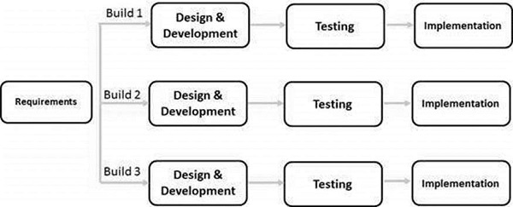

## **Iterative Model – Application**

## This model is most often used in the following scenarios −

* Requirements of the complete system are clearly defined and understood.
* Major requirements must be defined; however, some functionalities or requested enhancements may evolve with time.
* There is a time to the market constraint.
* A new technology is being used and is being learnt by the development team while working on the project.
* There are some high-risk featu Better res and goals which may change in the future

The advantages of the Iterative and Incremental SDLC Model are as follows −

* Results are obtained early and periodically.
* Progress can be measured.
* Less costly to change the scope/requirements.
* Risk analysis is better.
* It supports changing requirements.
* suited for large and mission-critical projects.

The disadvantages of the Iterative and Incremental SDLC Model are as follows −

* More resources may be required.
* Although cost of change is lesser, but it is not very suitable for changing requirements.
* More management attention is required.
* Defining increments may require definition of the complete system.
* Not suitable for smaller projects.
* Management complexity is more.